**Contours**

In relatively simple glyphs like the letter c shown in FIGURE 4, the sequence of points defining the glyph combine to form a closed shape termed a contour. In more complex glyphs like the letter B shown in FIGURE 5 below, sequence of points define three distinct closed shapes, each being a contour.

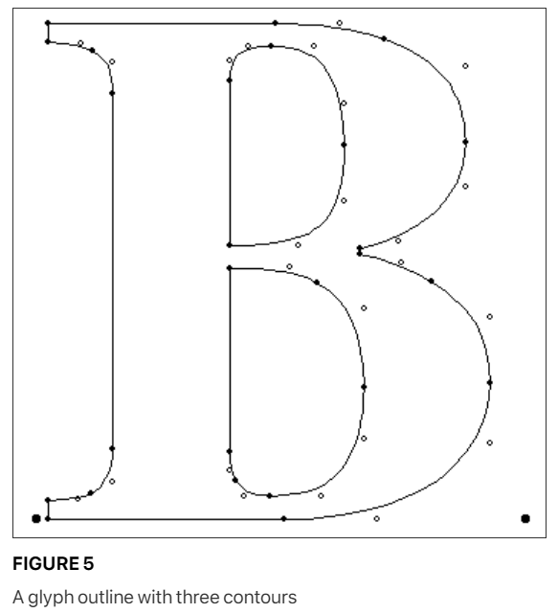

As can be deduced from these examples, glyphs can have zero or more contours. (The space glyph, which has an advance width but no other visible manifestation, has zero contours.)

**The direction of contours:**

In defining a contour, a font manufacturer must keep a number of rules in mind. The points in a contour must be ordered consecutively beginning with, in case of the first contour, point 0. Subsequence contours will begin with the first unused number. It must be possible to trace around each contour by going from point to point along the contour in the order specified in the font file.

The order in which points are specified is significant because it determines the direction of the contour. The direction is always from lower point number toward higher point number.

The direction of a glyph’s contours is used to determine which portions of shape defined by the contours is filled (black) and which portions are unfilled (white).

In making this determination, TrueType uses the non-zero winding number rule. See **Distinguishing the inside from the outside of a glyph** for information on the application of this rule.

**Intersecting contours:**

TrueType allows for the possibility that two contours might intersect. This feature can be convenient in describing the outlines of letters such as the Q. In such cases, the non-zero winding number rules is invoked to determine the appropriate fill. Black filled areas when placed over other black filled areas will remain black. AN example of this effect is shown in FIGURE 6 below.

